**(Original Field in Odoo)**

The state field in sale.order has values like:

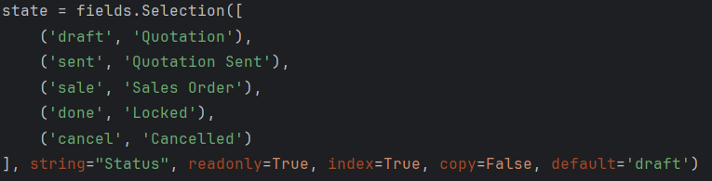

**After (Inherited and Modified)**

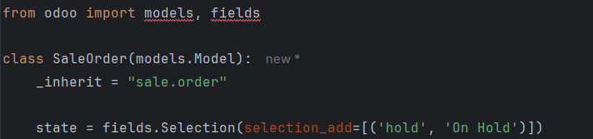

**Explanation**

* _inherit = "sale.order" → Inherit the sale.order model.
* selection_add=[('hold', 'On Hold')] → Adds a new selection option.
* No need to redefine all existing options; Odoo will append the new value.